SF - Site 15 – Lease Shapcolf Moving Co. 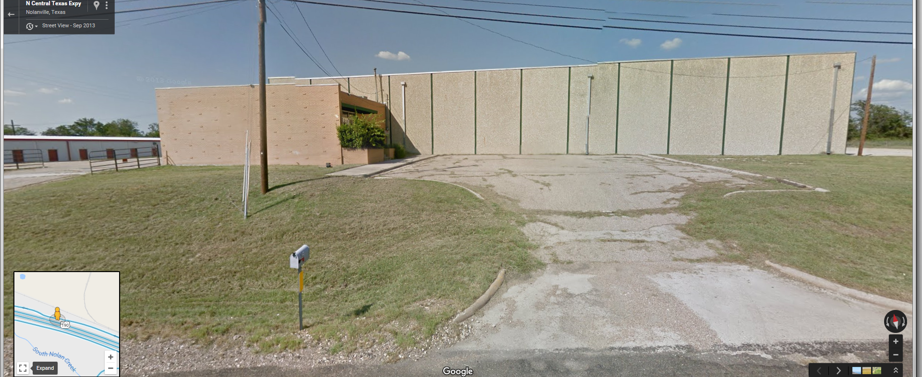
Cloud Real Estate
1703 South W.S. Young Drive
Killeen, Texas 76543
Office: 254-690-3311 Fax: 254-690-3430
Email: cloud@cloudrealestate.com
Former Shapcolf Moving Company
HWY 190 Access Road

SF - Site 15 – Lease Shapcolf Moving Co.
Property
Total Square Feet: | Map: Bell County Appraisal District h
Location
City: Nolanville | County: Bell
Address/Directions:
Within City Limits: Yes | Distance from City Limits: Within City Limits
Distance to Interstate Highway(s): Distance to US Highway(s):

General Site Information
Previous Use of Site: General Condition: Dimensions:
Soil Composition (based upon USDA, Soil Conservation Service, Soil Survey, Kaufman and Rockwall Counties, TX612): http:// websoilsurvey.nrcs.usda.gov/app/WebSoilSurvey.aspx | Shrink/Swell Capacity:
Adjoining Acreage Can Site Be Divided: Lot Size(s): Zoning:
Available:
Improvements
Rail Served: No |  | Name of “nearest” Railroad:
Proximity to Port(s): Approximately 3.5 hours to Port of Houston |  | Other Improvements: TXDoT daily traffic counts along I-14 were _________ cars per day (both directions) in (year).
Fenced: | Landscaped:
Located within an Industrial Park: | Type of Business Park, if applicable:
Deed Restrictions: | Covenants:
Utilities
Water/Wastewater: 439 Water Supply (254-939-8203) and Bell County WCID #3 (254-698-6885) | Water, size of nearest line:  Wastewater, size of nearest line:  and pressure:
Electric: | Phone: Facs: Email:
Natural Gas: Atmos Gas, (Contact Name, Phone, Email) | Size of Nearest Line: Pressure:
Telecommunications: (Name, Company,  Phone #)  Or (Ex. AT&T, Suddenlink) Phone: |  | Email:
Solid Waste Disposal: (Contact Name),  Texas Disposal Systems Phone: 512-421-1300 |  | Email:

