8 Acres - Site 20 – David Barr
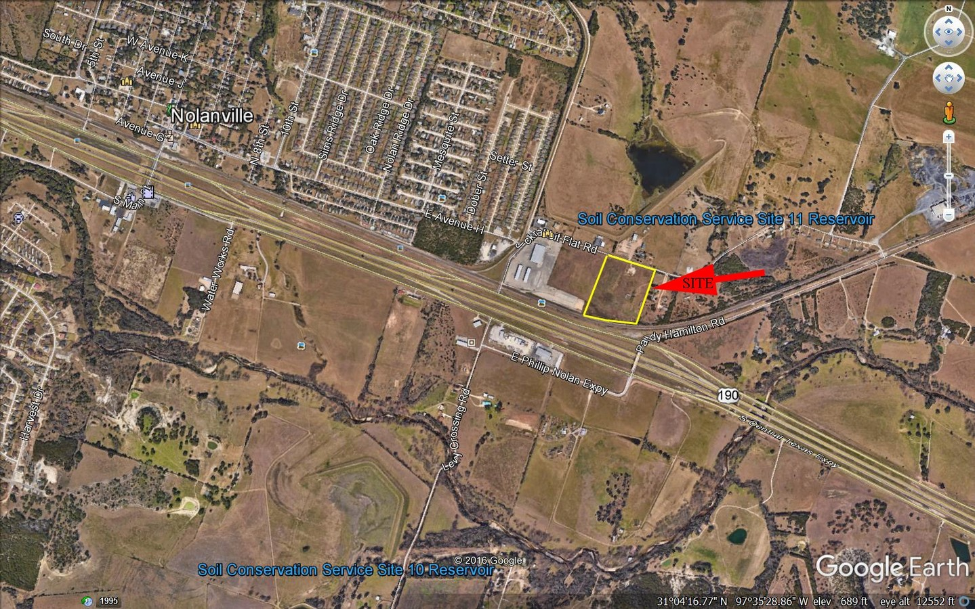
David Barr

NOLANVILLE, TX

8.acres
0 Jackrabbit Road
Nolanville, TX 76513
(Description of location)
www.bellcad.org, Property ID:

254.526.2277
david.barr@davidbarrproperties.com

Notes: 2 lots for commercial or Industrial use. WCID # 3 water is available. No sewer. Septic required. The property is outside of the Nolanville City limits, but it will be annexed when the water line is extended. WCID #1 water line easement is across the back sides of the lots, but cannot be tapped. E. on CTE to Nolanville. Exit Paddy Hamilton Rd. & go over the overpass. Turn left & turn right on Jackrabbit Rd. The property starts at the corner of Foxworth Galbrarth's Fence.
8 Acres - Site 20 – David Barr
Property
Total Acreage: 8 acres | Map: Bell County Appraisal District Parcel ID
Location
City: Nolanville | County: Bell
Address/Directions:
Within City Limits: Yes | Distance from City Limits: Within City Limits
Distance to Interstate Highway(s): Distance to US Highway(s):

General Site Information
Previous Use of Site: General Condition: Dimensions:
Soil Composition (based upon USDA, Soil Conservation Service, Soil Survey, Kaufman and Rockwall Counties, TX612): http:// websoilsurvey.nrcs.usda.gov/app/WebSoilSurvey.aspx | Shrink/Swell Capacity:
Adjoining Acreage Can Site Be Divided: Lot Size(s): Zoning:
Available:
Improvements
Rail Served: No |  | Name of “nearest” Railroad:
Proximity to Port(s): Approximately 3.5 hours to Port of Houston |  | Other Improvements: TXDoT daily traffic counts along I-14 were _________ cars per day (both directions) in (year).
Fenced: | Landscaped:
Located within an Industrial Park: | Type of Business Park, if applicable:
Deed Restrictions: | Covenants:
Utilities
Water/Wastewater: 439 Water Supply (254-939-8203) and Bell County WCID #3 (254-698-6885) | Water, size of nearest line:  Wastewater, size of nearest line:  and pressure:
Electric: | Phone: Facs: Email:
Natural Gas: Atmos Gas, (Contact Name, Phone, Email) | Size of Nearest Line: Pressure:
Telecommunications: (Name, Company,  Phone #)  Or (Ex. AT&T, Suddenlink) Phone: |  | Email:
Solid Waste Disposal: (Contact Name),  Texas Disposal Systems Phone: 512-421-1300 |  | Email:

